Low BTU Flare Tip Technology Breakthrough

A Key Enable of Net Zero

N. Amarutanon, B. Assavanives, K. Watanakun, S. Jairakdee, N. Rakpratanporn, N. Muangsuankwan, N. Sayatanan, K. Sinthavarayan, S. Watcharasing, PTT E&P PLC, Thailand; and Z. Kodesh, W, Davis, JZHC, USA

Abstract

To achieve net-zero ambitions in the oil and gas industry, the reduction of greenhouse gas emissions poses a significant challenge. Existing technologies, including lean gas flare tips, have limitations in effectively reducing emissions. In response to this challenge, a breakthrough invention was pursued through RD&T (Research, Development, and Testing) to create a new technology: the Extremely Low BTU flare tip. This innovative invention promises to play a pivotal role in enabling the industry to reach its net-zero targets.

At present, conventional oil and gas production is continuing to release a significant amount of greenhouse gas (GHG). In the gas sector, the gas sweetening process using membrane technology has been deployed for a long time to remove CO2 from feed gas is a common approach. As membrane technology improves, the resulting waste gas (permeate gas) methane concentration declines, and this gas must be disposed (flared). Flaring of low BTU gas containing more than 85% inert gas (approximately 140 BTU/scf lower heating value (LHV)) is problematic. Many flare tip technologies available in the market require the flare gas heating value to be at least 200 BTU/scf or higher to achieve flame stability and ensure complete combustion. To achieve this higher heating value, a large amount of assist gas is injected into the flare gas resulting in higher GHG emissions e.g., 5 MMscfd of methane gas.

Recognizing the urgency to reduce GHG emissions, we embarked on a joint research and development project to address the limitations of high heating value requirements by launching the Extremely Low-BTU Flare Tip development project. The project plan was to focus on the gap of existing technology and theories behind low heating value gas combustion and invent an innovative design by adding features to enhance the capability and completeness of low-heating-value gas combustion while ensuring safe operation in offshore environments. The RD&T research project included multiple iterations of prototype design, simulation, and testing, with various parameter adjustments to optimize the performance against the completeness of combustion criteria. The final design has been proven by a series of prototype tests to reinforce the level of confidence in its performance and mechanical integrity.

The final design of the Extremely Low BTU flare tip prototype was proven to successfully combust lower heating value flare gas, and significantly outperforming existing technologies. The test results showed that the Extremely Low BTU Flare Tip has the capability to combust flare gases with an LHV as low as 45% lower than existing flare tip technology which requires LHV higher than 200 Btu/scf. By using the Extremely Low BTU Flare Tip, operators will be able to minimize hydrocarbon loss and GHG emissions, save raw gas, and gain more revenue.

The Front-end Engineering Design (FEED) and details engineering have been completed to deploy the new technology in one of the offshore gas fields in Gulf of Thailand. Flare Tip dimensions have been adjusted to fit for brownfield modification within limited space on the flare tip platform. In July 2024, the installation at the brownfield facility was successfully completed as planned. The research team then continued with commissioning and field testing, yielding satisfactory results. A drone equipped with visual and thermal cameras was used to monitor and investigate the functionality of the Extremely Low BTU flare tip. The intensive field test program proved that all functions of the new technology met expectations, and the required flare gas heating value can be reduced from at least 200 BTU/scf to 160 BTU/scf based on the actual limitations of field operation. There is potential for lowering the required heating value to 110 BTU/scf, depending on the performance of the CO2 membrane.

Regarding the actual field test at offshore environment result, the new technology is suitable to apply for offshore operation with an expected cost saving $10-31 MMUSD per year per platform, depending on the lowest achieved heating value. Moreover, GHG reduction is 60,000 – 300,000 Tons of CO2 equivalent per platform, further advancing the industry's progress towards achieving its net-zero targets.

Introduction

Natural gas production releases a significant amount of Greenhouse Gas (GHG) into the atmosphere. The gas sweetening process using membrane technology is no exception. Significant advancement in CO2 removal via membrane has resulted in extremely low-BTU waste gases containing more than 85% CO2 which is equivalent to a lower heating value (LHV) of 140 BTU/scf. However, for CO2 diluted waste streams, current flare technologies require the flare gas LHV to be between 180 to 300 BTU/scf to maintain flame stability and ensure complete combustion. To achieve this heating value, a large amount of assist gas is injected into the flare gas. Consequently, the benefit of the more efficient membrane technology is lost and the amount of GHG emission is increased at the production site. By developing a technology that can efficiently combust waste gases that are significantly less than 180 BTU/scf, the operator will be able to significantly reduce the amount of assist gas injection, thereby gaining more revenue and reducing greenhouse gas emissions at the platform.

We recognized the need for better technology that could effectively combust high CO2 diluted waste streams. The Extremely Low-BTU Flare Tip development project was launched as a joint research and development project between PTTEP and John Zink Hamworthy Combustion (JZHC), a world-class flare manufacturer. The innovative design is based on theories behind low heating value gas combustion and improves upon existing low-BTU flare technology. The project plan was to invent a new design by modifying/adding features to enhance the capability and completeness of low-heating-value gas combustion.

The joint research and development project began work in 2018. The innovation of new technology occurred from; a literature survey on lean gas combustion theory, a review of technology currently in the market, a brainstorm of innovative ideas for flare tip design, and finally a series of prototype tests. This project included multiple iterations of prototype design, simulation, and testing, with various parameter adjustments to optimize the performance against the completeness of combustion criteria. The design was studied through computational fluid dynamics (CFD) simulation and tested to determine the operating envelope of the Extremely Low-BTU Flare Tip. The final design has been proven by a series of prototype tests to reinforce the level of confidence in its performance and mechanical integrity.

With a high level of confidence in RD&T prototype test results, one of the gas fields in Gulf of Thailand is interested to be the pioneer project to install the new lean gas flare tip technology with the objective to reduce GHG emission. Therefore, Front-end Engineering Design (FEED) Package was performed to identify the technical challenge of brownfield modification work for lean gas flare tip replacement in 2024.

In FEED, Flare Tip dimensions have been adjusted to fit for brownfield modification within a limited space on the flare platform. Regarding the FEED result, the new technology is suitable to apply for offshore operation. The decision to sanction this project was granted. The EPCIC with the target to install and commission in 2024 was continued accordingly.

In July 2024, the installation at the brownfield facility was successfully completed as planned. The research team then continued with commissioning and field testing, yielding satisfactory results. The intensive field test program proved that all functions of the new technology met expectations, and the required flare gas heating value can be reduced from at least 200 BTU/scf to 160 BTU/scf based on the actual limitations of field operation. There is potential for lowering the required heating value to 110 BTU/scf, depending on the performance of the CO2 membrane.

Existing Pain Points

Existing available lean gas flare tip technologies in the market have certain limitations. It requires a minimum of 180 BTU/scf (CO2 dilution) to maintain flame stability and ensure complete combustion of flare operation within a Reliable Operating Window. Many regulatory agencies require a minimum heating value of 200 BTU/scf to help ensure stable combustion. Adhering to this criteria, continued GHG emission at the current rate is foreseen.

In contrast, the membrane technology efficiency has significantly improved over the last decade. The permeate gas (lean gas flare gas) has a heating value lower than 140-160 BTU/scf which is significantly lower than 200 BTU/scf. The lean flare gas is released to the existing lean gas flare tip which has a flare gas minimum heating value requirement of 200 BTU/scf. The benefit of higher membrane efficiency has been destroyed as per the abovementioned.

Currently, there is no commercialized Flare Tip capable of effectively combusting CO2 rich waste gases at heating values significantly lower than 180 BTU/scf. A product that fits company’s requirements is unavailable, hence company was required to develop their own technology.

Journey of RD&T of Extremely Low-BTU Flare Tip development project

Starting with the realization of existing pain points and an ambition to reduce GHG emissions, RD&T road map has been initiated since 2018 by PTTEP. In cooperation with John Zink Hamworthy Combustion, a joint research team started to invent the new technology step-by-step as follows and Figure 1.

* Pain point identified
* Performed literature survey of lean gas combustion theory
* Evaluated available existing flare tip technologies
* Framed the requirements and general functions that must be achieved
* Established cooperation with JZHC as a joint research team
* Designed a test tip to explore the efficacy of existing lean gas flare tip elements and the efficacy of some new elements
* Tested initial tip to define the boundary of operation with various elements active
* Used the data from the initial test program to develop a prototype design for improved performance
* Conducted Computational Fluid Dynamics (CFD) on prototype design to identify issues / concerns
* Modified prototype design to address issues identified by CFD
* Finalized the prototype design and fabricated test flare tip
* Conducted series of tests on the prototype tip and analyzed tests results
* Finalized the new design of flare tip
* Decided to pursue FEED for brownfield installation
* Conducted FEED to enhance the maturity of design and confidence in field trial test
* New flare tip technology for lean gas flare to be installed on the Great Bongkot South (GBS) brownfield gas production platform in the Gulf of Thailand in 2024
* Installation and field test run were completed in July 2024, the new technology reduce GHG emissions 60,000 -200,000 Tons of CO2 equivalent per year and have a cost savings of $10-31 MMUSD per year

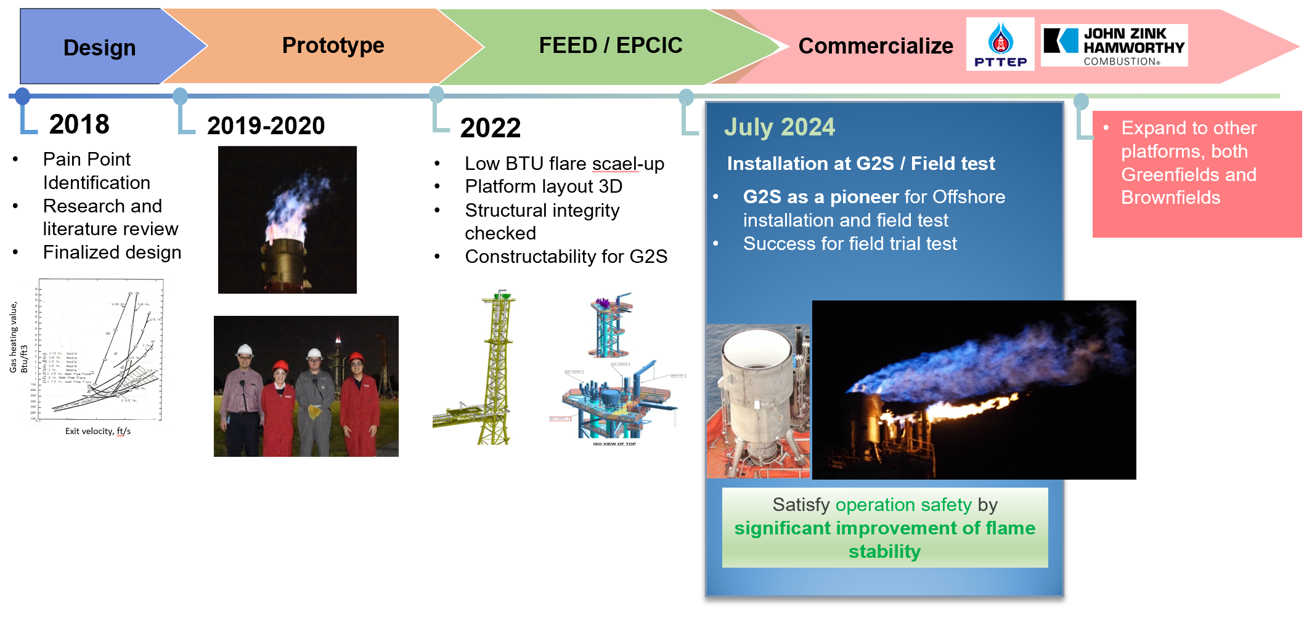

**Figure 1** Road map of Extremely Low-BTU Flare Tip development project

Statement of Theory and Definitions

1. Framing the requirement and general functions that must be achieved

The new flare tip had to meet the performance criteria described below and Figure 2 to achieve flare tip’s functioning for safety integrity of the oil and gas facility.

1.1 Maintain flame stability

Flare shall be continuously ignited at all times and flame out shall not occur at any wind condition to ensure that flare is functioning during both emergency and non-emergency conditions, preventing unburned hydrocarbon release to atmosphere.

1.2 Minimizing burn-back

Flame shall reside in the designated flame zone of the flare tip. Burning of flare gas in non-flame areas inside the flare tip can greatly reduce tip life by deforming portions of the tip.

1.3 Minimizing flame pull-down

As wind blows across a flare tip, a low-pressure zone is formed on the downwind side of the tip resulting in flame pull-down on that side. Flame pull-down can potentially damage the flare tip. The new flare design shall mitigate flame pull-down, so it does not impact tip life.

4) Ensuring Mechanical Integrity

The flare tip and its components are exposed to a flame temperature of about 550° C continuously. In order to ensure that the new flare tip service life is long, the mechanical integrity over the service life of the new flare tip must be achieved.

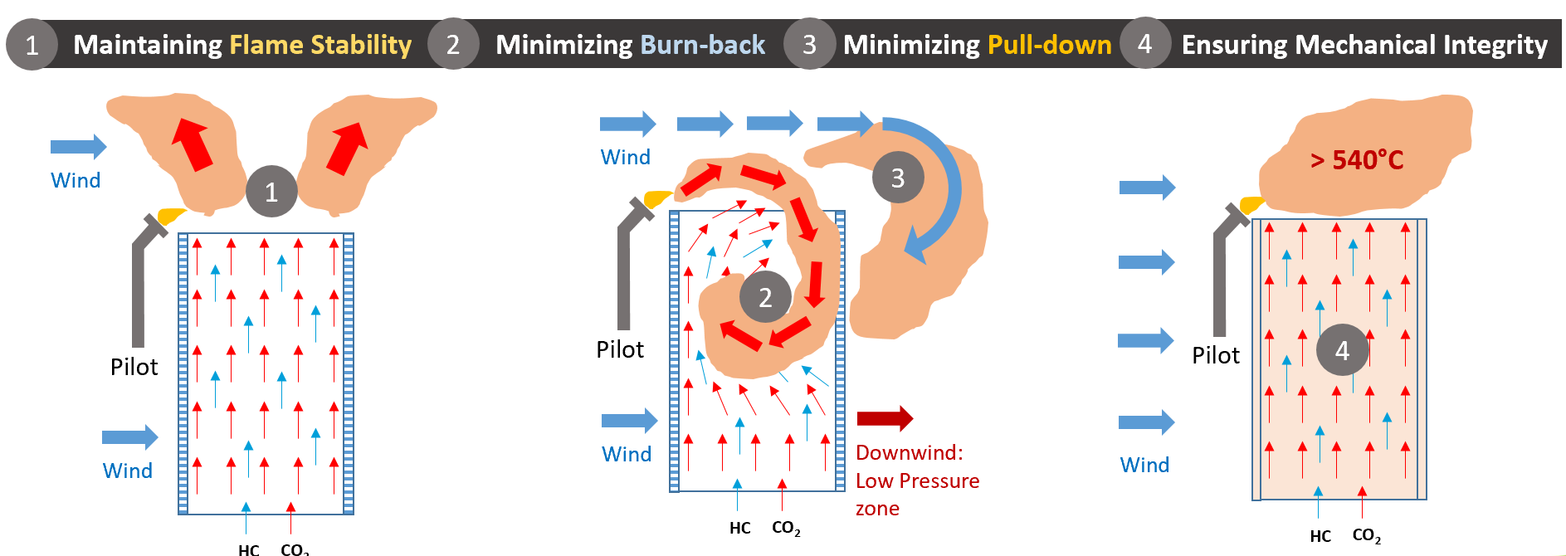

**Figure 2** 1) Flame stability, 2) Flare tip burn-back, and 3) Flame pull-down 4) Ensuring Mechanical Integritry

2. Literature survey of lean gas combustion theory

The lean gas combustion has its own specific characteristic beyond typical rich hydrocarbon mixture. With low concentration of hydrocarbon, it leads to difficulty for burning and requires special operating envelop. There are several literatures, papers / reports that demonstrate the experimental theory of lean gas combustion with various parameters. To breakthrough the existing technology limitation of lean gas combustion in a flare, the available information was reviewed as follows.

2.1 Air-enriched flare gas

The impact of CO2 dilution of methane is presented in Figure 3. This figure depicts the flammable zone of mixtures with different amounts of methane, diluent, and air. The straight line through the graph (*Cst*) represents the stoichiometric amount of air for the given amount of methane. As can be seen from Figure 3, CO2 (red curve) is more detrimental to combustion than helium, nitrogen, and water. Investigating this figure further shows that the maximum dilution of methane with CO2 that will burn is approximately 3.25 volumes of CO2 per volume of methane. This works out to a mixture LHV of 215 BTU/scf. It should be noted that operation on the edge of this curve is not commercially viable since the flame speed on the curve edge is very slow and ambient air diffusion into the waste gas would quickly outrun the flame front, diluting the waste gas below its flammability limit. Hence the challenge of lean gas combustion with CO2 dilution is very real. Figure 3 shows that if the inert/methane mixture passes through the flammable envelope, it can burn. The red arrow shows a mixture that won’t burn. Shifting the starting position to the left improves combustion so that the green arrow shows a mixture that will burn.

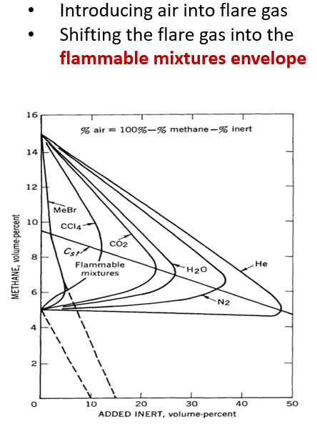

**Figure 3** Excess air to enrich the lean gas mixure

2.2 Addition of Assist Fire to outer edge of flare tip and to spokes that extend into the flare tip

The assist fire is a rich gas flame that surrounds the discharge of the flare tip as well as penetrates into the waste gas discharge. The assist fire is added to the flare tip to promote the combustion reaction due to following reasons:

* The assist fire will help to increase temperature of flare gas and thus expand the flammable mixture range. As can be seen from Figure 4, at higher temperatures of flare gas, the flammable range is expanded.
* The assist fire will cause some of the flare gas to exceed the auto-ignition temperature. If the flare gas is above the auto-ignition temperature (540°C for methane) then the methane will oxidize in the presence of oxygen even if an ignition source is not nearby.
* The assist fire will generate combustion radicals such as OH, H, O, etc. Once the radicals are created, they will enhance the rate of combustion reaction because they are highly reactive substances.

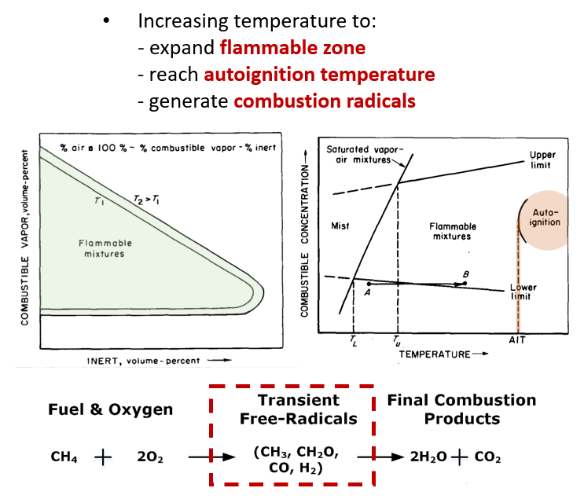

**Figure 4** Effect of initial temperature on limits of flammability of a combustible   
vapor-inert-air system at Atmospheric pressure and in Air at a Constant Initial Pressure1

2.3 Maximizing Retention Time of combustion

According to the studies conducted by Pohl and Soelberg (2014), Figure 5 shows the relationship between exit velocity and heating value. It can be observed that lower heating values require lower exit velocities to maintain flame stability. Reduced velocity causes reduced air entrainment of ambient air, and it facilitates flame attachment to the flare tip discharge. Excessive air entrainment of lean gases can drop the flare gas / air mixture below the hydrocarbon’s flammability limit, allowing that hydrocarbon to vent. Air entrainment is a combination of flare gas density (no control over this parameter), flare gas exit velocity (determined by tip design) and burning condition (attached or detached flame). A detached flame (flame lift off) allows rapid entrainment of ambient air with the flare gas between the flare tip discharge and the start of combustion. An attached flame will also have air mix into the flame, but it will be at a lower rate due to the expanding products of combustion causing a shielding effect that the air must overcome. Therefore, to ensure the flare gas jet doesn’t entrain too much ambient air as well as ensure the flame is attached to the tip, the flare gas exit velocity is reduced.

The new flare tip technology explored a range of exit velocities. Finding the maximum allowable exit velocity is commercially important since the higher the design exit velocity, the smaller the tip and the lower the capital cost. At the same time, the exit velocity needs to be low enough to ensure stable combustion.

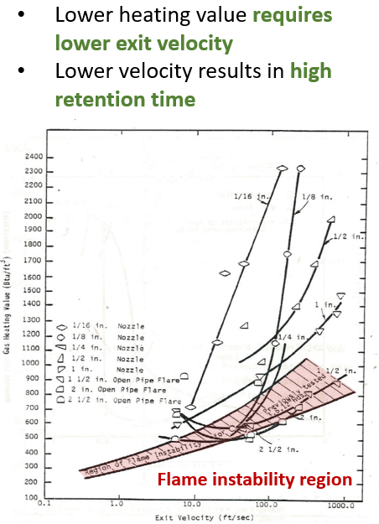

**Figure 5** Flame Stability, Exit velocity versus Gas Heating Value2

3. Framing the ideas of new technology then generated the first design version

The innovative design of the Extremely Low BTU Flare Tip, shown in Figure 6, consists of assist fire around the tip perimeter discharge and on spokes that penetrate the flare gas discharge. The assist fire is designed as an “assist gas burner” where assist gas and assist air are delivered to these elements. Jet-pumps are used to supply assist air to the assist gas burner, minimizing the line size for assist air. With this design, assist gas and assist air are well mixed producing stable combustion and providing heat to the flare gas. A top hat was introduced to mitigate wind impact. The top hat retards mixing of ambient air with the flare gas, re-radiates heat to the flare gas, and increases the time the flare gas remains at elevated temperature. All these benefits allow combustion of the assist gas and subsequent mixing of combustion radicles with the flare gas without the impact of wind. Two of the major elements, assist fire ring and spokes, were borrowed from existing tip designs which have proven reliable over decades of operation.

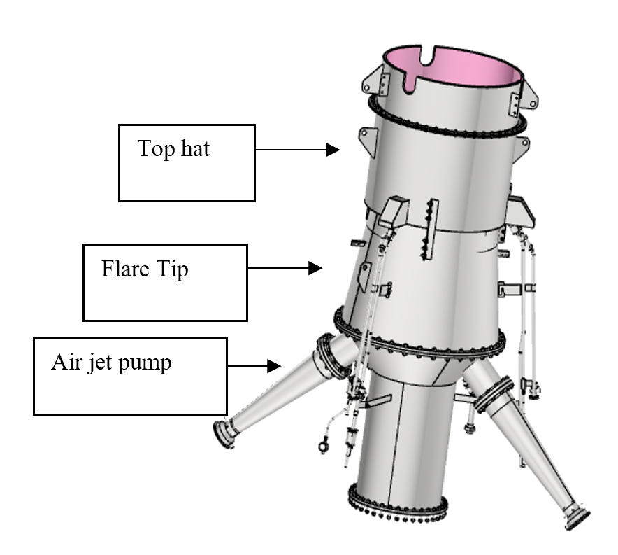

**Figure 6** Extremely Low BTU Flare Tip design (elevation view and top view)

Data and Results

4. Prototype testing

The prototype test investigated flare tip performance by varying flare gas LHV, flare gas exit velocity, assist air flowrate, assist gas flowrate (related to heat release), with & without wind generator, and with & without top hat. The wind generator was an upgrade to the test facility. The wind generator created a crosswind across the tip in excess of 20 mph (32 km/h). The performance envelope was generated based on the acceptable operating points regarding two performance aspects of the flame characteristic i.e., flame stability and flame quality.

* Final design after 13 variations of design have been tested
* More than 40 various conditions were tested to obtain final operating envelope
* More than 130 test runs to confirm its performance, mechanical integrity, and confident design zone

After hundreds of tests, it was found that the Extremely low BTU flare tip was able to combust a vent gas having an LHV as low as 110 BTU/scf, with acceptable flame stability and flame quality, see example in Figure 7. For mechanical integrity, which is a crucial factor to ensure that the Extremely Low BTU flare tip will have an acceptable service life, the internal and external parts of the protype were thoroughly investigated before and after testing. It was concluded that the design should have acceptable mechanical integrity for this application.

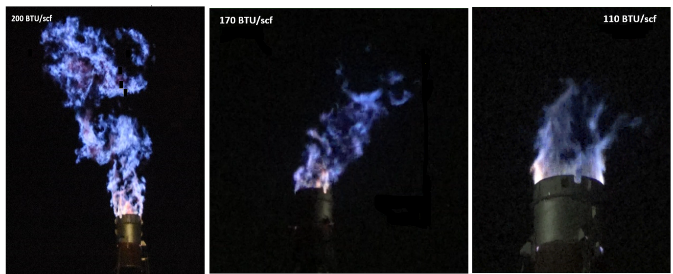

**Figure 7** Flame stability, flame quality of Extremely low BTU flare tip based on prototype testing

4.1 Flame Stability Test

The assist gas flame (ring and spokes) was observed to be stable regarding its continuity and consistent length. CO2 was flowed through the tip while the assist gas was burning to ensure the assist gas flame from the spokes would not be extinguished when surrounded by a gas containing no oxygen. During the flow test, the assist gas flame was stable and well anchored. Figure 8 shows the stability of the lean flare gas flame generated from new flare tip prototype.

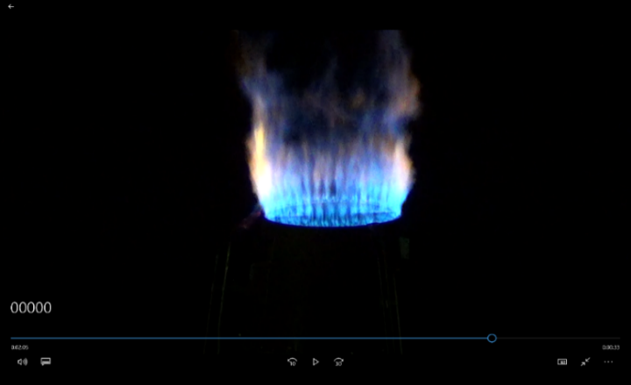

**Figure 8** Flame stability around Extremely low BTU flare tip

4.2 Flame Quality

Flame quality was visually observed by the qualitative measures of the flame which includes the stability of the flame, the continuity of the flame and the flame length compared to the given heat release of the vent gas.

5. Front-End Engineering Design (FEED) for GBS brownfield installation

With successful prototype test results, it was agreed to pursue next step by actual installation on Greater Bongkot South (GBS) gas field facility in Gulf of Thailand in 2024 as a commercial scale test on an operating platform. An intensive FEED study was conducted which included fine-tuning the operating envelop, modification of piping and platform layout with 3D model, pipe stress analysis, structural integrity checked, and verification of flare dispersion and radiation. During FEED, a detailed study of installation methodology was conducted to confirm the movement and installation of the tip could be accomplished safely.

In FEED, Flare Tip dimension was adjusted to fit for brownfield modification within limited space on the flare tip platform. The intensive HAZID, HAZOP, ENVID, and Technology Risk Assessment workshops were conducted to investigate and register the safeguarding to enhance the design maturity of new technology contributing to confidence that the flare will operate as expected and not have unforeseen issues. Highlighted FEED work as follows.

5.1 3D Model of Piping and Platform Layout

Extremely Low BTU Flare Tip and associated pipes will be installed at the top of the Flare Platform as shown in Figure 9. 3D modeling was done to confirm space availability.

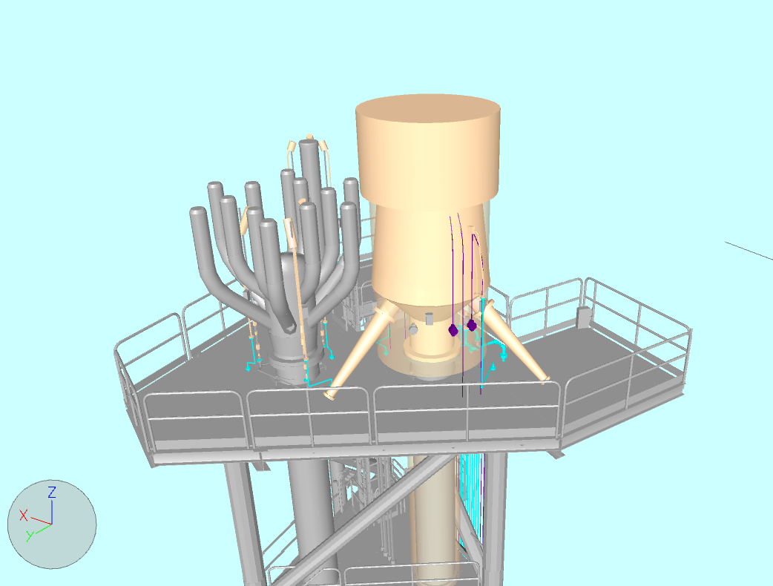

Extremely Low BTU Flare Tip

**Figure 9** 3D model of ExtremelyLow BTU Flare Tip on GBS flare platform

5.2 Pipe Stress Analysis

Overall, the pipe routing and pipe support have been reviewed by performing pipe stress analysis. Pipe stress values have been checked in accordance with relevant code and standard.

5.3 Structural Integrity Checked

The structural analysis was performed in accordance with the company’s specifications and requirements to ensure that existing Flare Platform South (FPS) to be adequate design from additional imposed loads of new Extremely low BTU flare tip during in-service conditions. All structures were designed with a working stress design method in accordance with API RP 2A WSD and AISC ASD.

Based on the results of the analysis above, it can be concluded that FPS tower platform has adequate structural integrity to accommodate the installation of new facilities of the project, as well as flare tip replacement.

5.4 Vent and Dispersion Study

The flare was evaluated for a venting condition (rich assist gas flame present but lean permeate gas doesn’t combust. The maximum extensions of flammable gas cloud corresponding to the Lower Flammable Limit (LFL) 100%LFL, 50% LFL and 10% LFL have been simulated. And the extent of the toxic gas of CO2 has also been assessed.

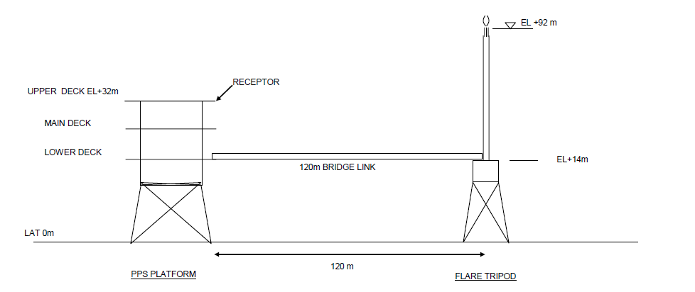

**Figure 10** Sketch of PPS (Processing Platform South) and FPS (Flare Platform South)

Flammable Limit: The governing case maximum horizontal distances and maximum vertical drop (HP Flare) for 100%, 50% and 10% LFL from existing flare tips are more conservative than result from the New Extremely Low BTU Flare tip case. There are no ignition sources in the maximum 100% and 50% LFL extents. Even if 10% LFL flare gases disperse above the PPS, WPS1 (Wellhead Platform South 1) monkey board (EL. 59,000), they do not drop enough to impact the gas detectors and personnel on board.

Refer to Figure 10, the maximum horizontal distance from New Extremely Low BTU flare tip of flammable gas corresponding 10% LFL is 128.5 m without vertical drop. The vertical height of flammable gas is more than 100 m hence it is considered that current flammable flare gases do not impact on Helicopter landing / take-of operation and helicopter approach. From the results obtained in the dispersion of flammable gas study, the New Extremely Low BTU Flare tip is acceptable for installation.

5.5 Toxic Concentration Study

Definition:

* TLV-STEL (Threshold Limit Value – Short-Time Exposure Limit): Used to quantity short-term exposure of personnel to toxic gas (less than 15 min and of 4 exposures per day maximum).
* TLV-TWA (Threshold Limit Value – Time Weighted Average): Used to quantity continuous exposure of personnel to toxic gas (8 hours a day or 40 hours per week).

For the maximum horizontal extent of TLV STEL (30,000 ppm) of CO2 for New Extremely Low BTU Flare and Existing, the maximum horizontal distance is 89.1 m without a vertical drop at 10 m/s wind speed and the maximum vertical drop is 28.8 m with 25.4 horizontal distance at 0.5 m/s wind speed. However, the maximum horizontal distance and maximum vertical drop of CO2 gas corresponding to TLV STEL (30,000 ppm) does not impact other platforms such as PPS, WPS1 monkey board and QPS helideck.

For the maximum horizontal extents of TLV TWA (5,000 ppm) of CO2 for the New Extremely Low BTU Flare tip, the maximum horizontal distance of CO2 gas clouds corresponding to TLV TWA is 272 m with a slight vertical drop (2 m). Considering the distance between FPS and QPS helideck (about 270 m) and vertical height of CO2 plume is more than 117 m, CO2 gas clouds from flare tip do not affect the helicopter operation. Considering horizontal distance of 117.0 m when the maximum vertical drop of 62.8 m and the distance between FPS and PPS, WPS1 and QPS, the maximum vertical drop does not impact to these platforms.

5.6 Flare Radiation Study

The thermal radiation at the closest upper deck edge of PPS, WPS1 edge, and Bridge at PPS was not governing and do not exceed criteria 4.7 kw/m2 and 2 kw/m2 for emergency and continuous flaring, respectively. However, the thermal radiation results at stack base exceed 6.3 kw/m2 and 2 kw/m2 during an emergency and continuous flaring, respectively.

The recommendation to mitigate the high thermal radiation at stack base that impacts working at height above bridge's heat shield during the installation period were as follows:

* Temporary platform (e.g., Access ladder) shall be provided for emergency escape every 20 m.
* Provide mobile heat shade (maintenance heat shield) which can be installed on scaffolding close to a working area.
* Heat stroke prevention by the provision of a continuous working period of the workforce at 45 minutes and take rest outside the working area for 15 minutes they shall drink total water 1,000ml minimum; recommend to drink water 250 ml every 15 minutes.
* Personnel who work at height above bridge’s heat shield shall wear appropriate clothing consisting of hard hat, long-sleeved shirt with cuffs buttons, work gloves, long legging pants, and work shoes to minimize direct skin exposure to thermal radiation.

Regarding the FEED result with highlighted work abovementioned, the new technology is suitable to apply for offshore operation. The decision to sanction this project was granted. The target to install and commission in 2024 has been continued accordingly.

6. Field trial test at GBS brownfield

In July 2024, the installation at the brownfield facility was successfully completed as planned. The research team then continued with commissioning and field testing, yielding satisfactory results. The intensive field test program proved that all functions of the new technology met expectations, and the required flare gas heating value can be reduced from at least 200 BTU/scf to 160 BTU/scf based on the actual limitations of field operation. There is potential for lowering the required heating value to 110 BTU/scf, depending on the performance of the CO2 membrane.

Conclusions

The goal of net zero GHG emissions in the oil and gas industry will have many challenges but it is possible with intensive team effort. Existing technologies such as lean gas flaring technologies, have reached their limits in reducing GHG emissions. Technological breakthroughs are necessary to advance the goal of net zero. RD&T to invent innovative technology for lean gas flaring was initiated from the PTTEP vision of net zero and after several years of hard work, it is ready for execution. Innovative technology can be incredibly difficult to develop but when successful it can significantly impact the environmental and commercial performance of a business.

The new flare tip technology was extensively tested onshore and has been approved for offshore installation, testing, and gas production. The first full scale installation was deployed to one of the offshore gas fields in the Gulf of Thailand in July 2024 with successful results contributing to confidence that the flare is operate as expected and not have unforeseen issues. Because this new technology allows reduced flaring of production gas, the platform expects to produce and additional $10 million to $31 million of additional gas sales per year per platform. Moreover, 60,000 – 300,000 Tons of CO2 equivalent GHG emissions reduction is expected per platform.

The research conducted these past years by PTTEP and JZHC has produced a technology (Extremely Low BTU flare tip) that operates more efficiently than existing low-BTU flaring technologies. The design has been validated with hundreds of prototype tests to ensure that flame stability and mechanical integrity. Test results have also provided the confidence needed to proceed to a field trial of a full-scale tip. The field testing at Great Bongkot South in the Gulf of Thailand has been intensive performed and has proven the design of the Extremely Low BTU flare tip technology. The invention of Extremely Low BTU flare tip technology will become a key enabler of the net zero targets of oil and gas industry. By utilizing the Extremely Low BTU Flare Tip, operators will be able to minimize hydrocarbon loss, minimize GHG emissions, and increase profitability.

Nomenclature

API American Petroleum Institute

AISC American Institute of Steel Construction

BTU British thermal unit

CFD computational fluid dynamics

EPCIC Engineering, Procurement, Construction, Installation and Commissioning

FEED Front-end Engineering design

FPS Flare Platform South

GBS Greater Bongkot South

GHG Green House Gas

HAZID Hazard identification

HAZOP Hazard and operability study

JZHC John Zink Hamworthy Combustion

LHV Low Heating Value

PPS Processing Platform South

PTTEP PTT Exploration and Production Public Company Limited

QPS Living Quarter South

TLV-STEL Threshold Limit Value – Short Time Exposure Limit

TLV-TWA Threshold Limit Value – Time Weighted Average

WPS1 Wellhead Platform South 1

Acknowledgements

Our team would like to express deepest gratitude to:

Napa Medheethunyapong, Vice President Facility Engineering Department, PTTEP

Bundit Pattanasak, Senior Vice President Technology Management Division, PTTEP

Pongpun Urarungroj, Vice President Technology Management Division, PTTEP

Supot Lertsakulsup, Vice President Thai Offshore Production Operations 2 Department

References

1. Zabetakis (1964). *Flammability Characteristics of Combustible Gases and Vapors*, The U.S Bureau of Mines published Bulletin 627
2. Pohl et al. (2014). Combustion Efficiency of Flares and the Effect of Wind